C++

Inheritance

2 weeks ago:

* Work your way through 5.2 stack​
* <http://www.cplusplus.com/doc/tutorial/classes/>​
* Create the following classes: Person (name, age, gender, pet), Dog (name, age, breed)​
* Create some people and give them pets​
* Dump / Display / Output everything​
* Create a pointer to an object​
* Investigate inheritance, add other pets into the system – cats, rabbits, snakes etc

Bank Holiday:

* Investigate object operators:​
* \*  &   .   ->   []​
* Constructors and member initialization​
* Static members​
* Const members

Repl.it

<https://repl.it/@JohnGlazebrook/c-classes-2>

Add a square:

<https://repl.it/@JohnGlazebrook/c-classes-3-inheritance-1>

Problem:

* want to treat the shapes the same
* want to remove duplicated code

<https://repl.it/@JohnGlazebrook/c-classes-3-inheritance-2>

Problem:

* want to remove suspiciously similar code
* square is a rectangle with more rules

<https://repl.it/@JohnGlazebrook/c-classes-3-inheritance-3>

Problem:

* calling base constructor Rectangle(int, int) is annoying

<https://repl.it/@JohnGlazebrook/c-classes-3-inheritance-4>

Problem:

* Shape has database stuff entangled in it
* Shape has logging things entangled in it

<https://repl.it/@JohnGlazebrook/c-classes-3-inheritance-5>

Super class

Sub class

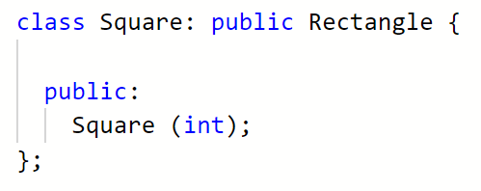

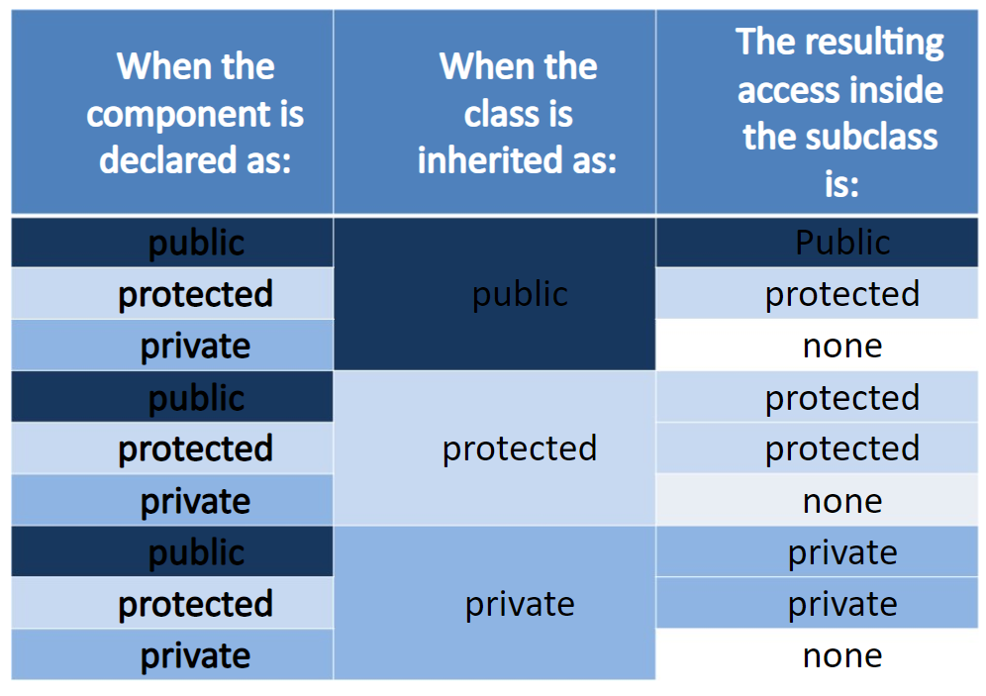

Complete all work so far ready to be checked over by the end of the day.